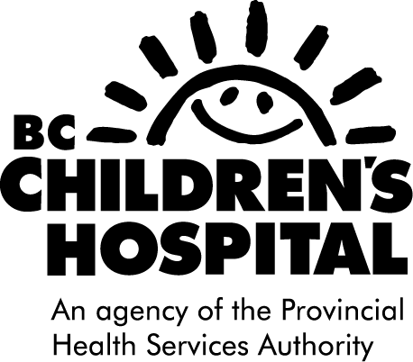
IMMUNOLOGY CLINIC
Dr. Catherine Biggs
Dr. Kyla Hildebrand
Dr. Elliot James
Dr. Stuart Turvey

Phone: 604-875-2118 ext 2 Fax: 604-875-3653
Mailing address: 1C31B 4480 Oak St Vancouver, BC V6H 3V4
Date:
To:
Fax: |  |  | Phone:
RE: | Referral |  | Pages: | (including this page)
From: |  |  | Fax: | 604-875-3653
Message: Urgent For Review Please Comment Please Reply
Patient Information:

Thank you and best wishes

If any pages are missing, please call The Immunology Booking Clerk, (604) 875-2118 ext 2

